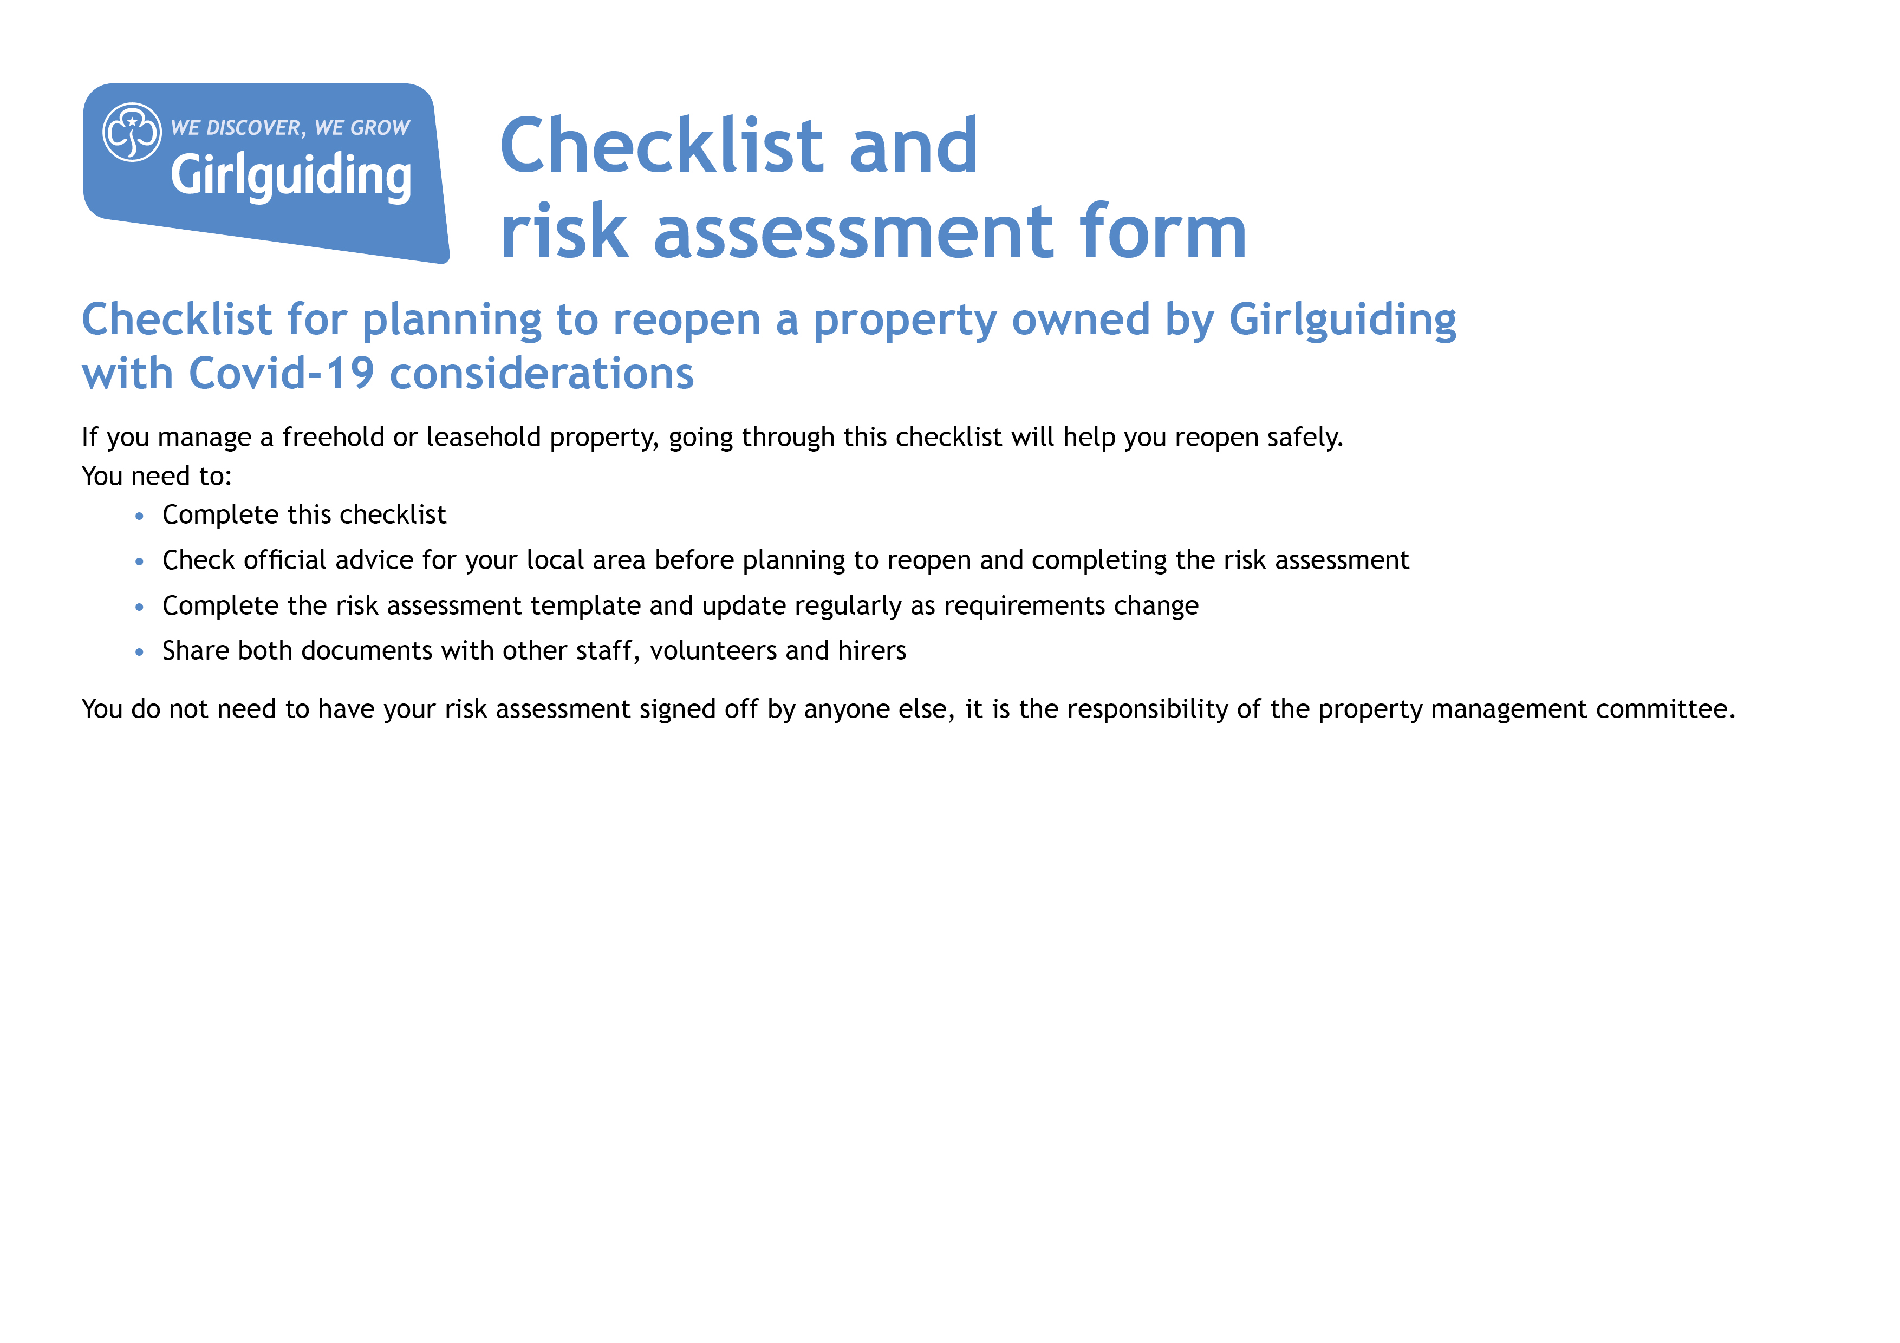

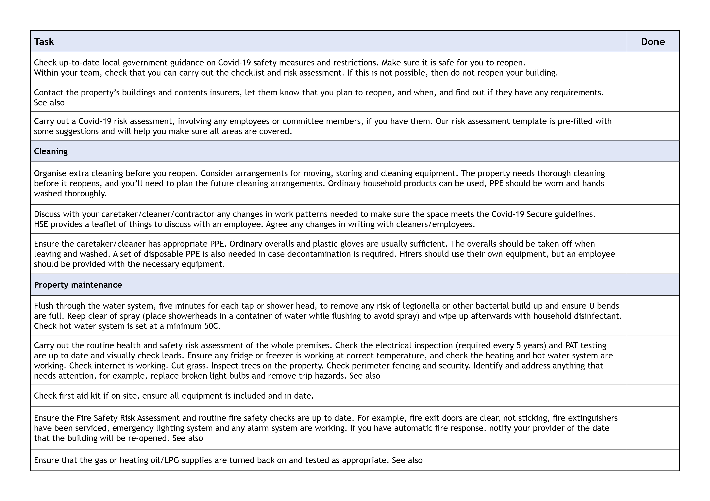
1/22
1/22
1/22

1/22
1/22
1/22
1/22
1/22
1/22
1/22
Be prepared: health and safety
Fire Risk Assessment pdf
Be prepared: health and safety
Insurance issues for property managers

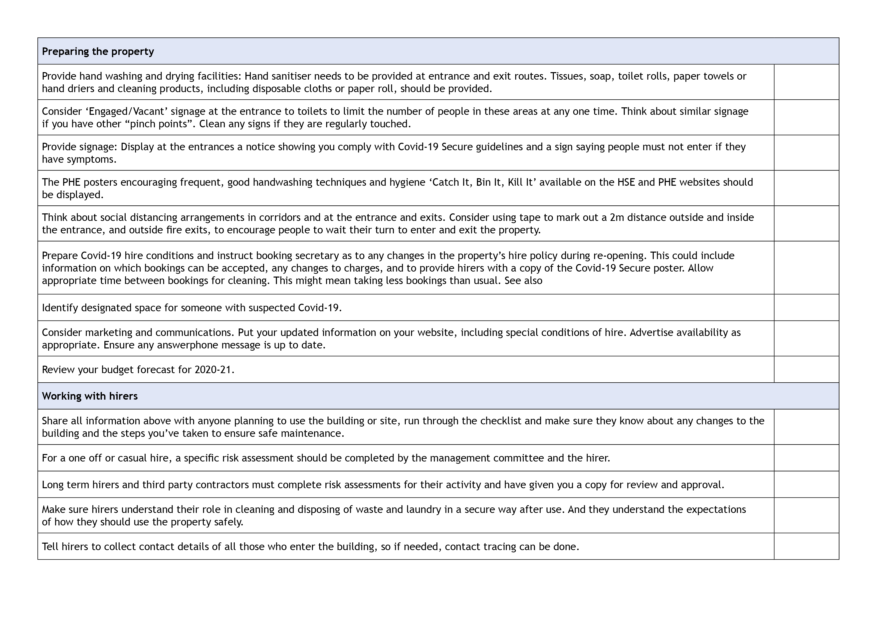
1/22
1/22
1/22
1/22
1/22

1/22
1/22
1/22
1/22
1/22
1/22
1/22
1/22
Hiring out your hall

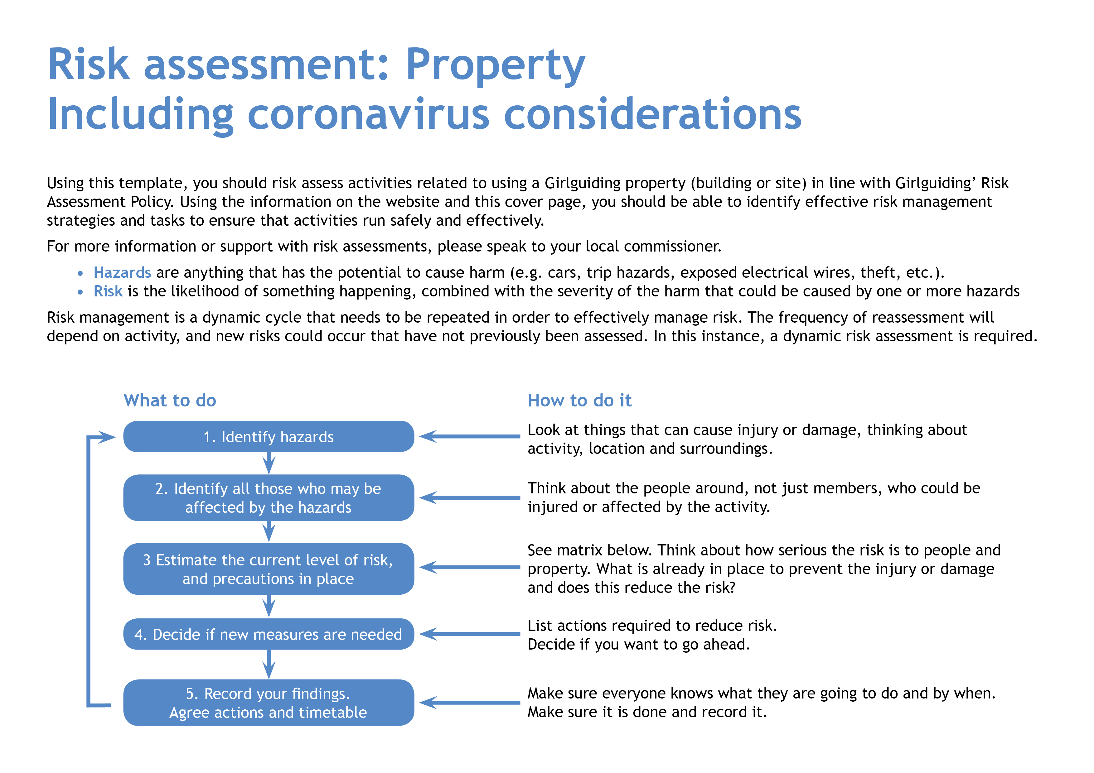

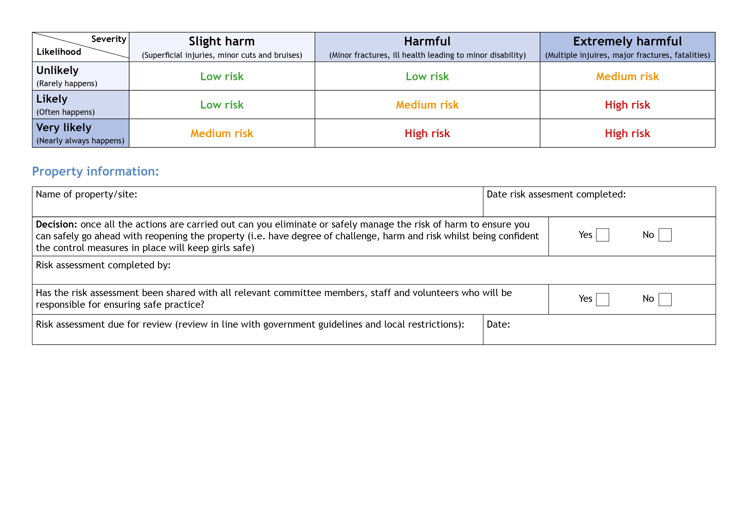
x

x
31/1/2022

Racheal Tattum and Susan Webb
31/1/2022
Dudsbury Guide Camp – Bournemouth Camp Association
Hazards  What could cause harm or damage? | Who or what is at risk of being affected and how? | What are you already doing?  How have you reduced the risk already? | Likelihood of risk occurring  (L/M/H) | Severity of risk  (L/M/H) | Are further controls necessary?  What else needs to happen to reduce the risk to an acceptable level? | Action by:  name/date
Long term closure means that systems may not have been working for an extended period.  This could mean that statutory compliance has not been maintained. | All users – may become ill or be  put at greater risk because systems  are not working correctly. | Make sure that all systems are re-commissioned before any meetings take place.  This must include checks for fire and water systems and gas safety. Checks should also be performed on heating and ventilation systems and emergency lighting.  Perform deep clean prior  to opening.  Complete checklist for reopening. | Medium | High | Consider employing specialists to carry out checks if not confident to do yourselves. Follow checklist to ensure that all relevant tests are carried out. | RT & SW 11/21  Fire Alarm checked -  PAT testing  Deep clean regularly carried out
Coronavirus infection risks below are in consideration of this risk and reducing it to an acceptable level. | All people using the facility from spread of virus through close contact. |  | Low | High |  | RT & SW 31/1/22
Staff, volunteers,  contractors and users. | All could be at risk of exposure to virus through their roles, likely to include those carrying out cleaning, caretaking or maintenance. | Discuss the situation with staff/volunteers in high risk groups to identify whether provision of protective clothing and cleaning surfaces is sufficient to mitigate their risks, or whether they should cease such work or volunteering for the time being. |  |  | Request RA and procedure for Covid-19 from contractors and users and review them.  Staff training/ regular briefing  of users.  PPE provision for staff/volunteers.  Cleaning regimes, all contact surfaces to be regularly cleaned.  Doors on automatic release to keep open on regular walk ways. Fire evacuation procedure to be updated if you have doors open to ensure doors closed when not  in use. | RT & SW 31/1/22

Hazards  What could cause harm or damage? | Who or what is at risk of being affected and how? | What are you already doing?  How have you reduced the risk already? | Likelihood of risk occurring  (L/M/H) | Severity of risk  (L/M/H) | Are further controls necessary?  What else needs to happen to reduce the risk to an acceptable level? | Action by:  name/date
All areas. | Potential for cross contamination and passing infection, between users. | Set out a procedure on what cleaning is required and how regularly this should be done for each hirer, include  door handles, light switches, window catches, tables, chairs and other equipment used to be cleaned by hirers before use or by property cleaning staff.  Cleaning between users – users to clean after use  Wardens will then deep clean after use | m | m | Detail chemical to be used for cleaning. Something with a bleach product – COSHH risk assessment required on product (assessment of working with hazardous materials). | RT & SW 31/1/22
Entrance halls/lobby,  in corridors. | Capacity for social distancing is reduced thereby increasing the risk to all users. | Check the number of users meeting at the venue at the same time. On forms  Work with hirers to plan the numbers that can be accommodated. – keeping in line with guidelines  hand sanitiser is provided for use.  Put a one-way system in place if necessary – use one door for entrance and one for exit. Users to implement on arrival  . |  |  | Reorganise booking times or change days and time in order to maximise capacity for all users and allow for cleaning in between.  Hand sanitiser needs to be  checked daily.  Bins to be emptied regularly. | RT & SW 31/1/22

Hazards  What could cause harm or damage? | Who or what is at risk of being affected and how? | What are you already doing?  How have you reduced the risk already? | Likelihood of risk occurring  (L/M/H) | Severity  of risk  (L/M/H) | Are further controls necessary?  What else needs to happen to reduce the risk to an acceptable level? | Action by:  name/date
Car parks/paths/patios/  exterior areas. | Start and end of meetings creates risk of breaching social distancing guidelines for property users and those dropping off or picking  up users. | Have a drop off and pick up process that is communicated to all users in advance.  Keep all external areas clear of contaminated rubbish. |  |  | Encourage those picking up and dropping off from cars to remain  in their cars. – users RA  Suggest to hirers that they limit drop off and pick up to one parent/carer/adult. On booking details  Consider staggered start and finish times for bookings.  Make sure that there is a 15 minute gap between hirers to ensure there can be no cross over between groups. | Users to aware of dropping off and collections  recommend. On users RA RT & SW 31/1/22
Main hall/meeting space. | Capacity for social distancing is reduced thereby increasing the risk to all users. | Set a limit on numbers attending – check relevant government guidance for your local area.  Remove unnecessary items from the hall/space - removed  Social distance guidance to be observed by hirers in arranging their activities.  Remove soft furnishings and things that are hard to clean from venue. |  |  | Users to check facilities on arrival  Social distancing posters around The House  General notices re hygiene on display  Discourage parents to enter the house at the start of events. | RT & SW 31/1/22
Small meeting rooms  and offices. | Capacity for  social distancing is reduced thereby increasing the risk  to all users. | Don’t use these rooms if social distancing cannot be observed. If use is required make sure that masks are worn if social distancing cannot be observed.  Have a one in one out system. |  |  |  | RT & SW 31/1/22

Hazards  What could cause harm or damage? | Who or what is at risk of being affected and how? | What are you already doing?  How have you reduced the risk already? | Likelihood of risk occurring  (L/M/H) | Severity  of risk  (L/M/H) | Are further controls necessary?  What else needs to happen to reduce the risk to an acceptable level? | Action by:  name/date
Kitchen. | Capacity for social distancing is reduced thereby increasing the risk to all users. | Ask hirers to control the numbers using the kitchen area so as to ensure social distancing.  Hirers to clean all areas likely to be used before use, wash, dry and stow crockery and cutlery after use.  Hirers to bring own tea towels.  Hand sanitiser to be provided.  Hirers to bring their own food and drink. |  |  | Cleaning materials to be supplied by the users  Users to think about numbers in kitchen  Keep doors open for air flow  Consider closing kitchen if not required or restricting access.  Disposable crockery (paper plates) and plastic/wood cutlery.  Users to include on their own RA | RT & SW 31/1/22
Use of shared resources. | Leads to risk of increased transmission. | Do not allow different user groups to use the same resources unless you can make sure that there is a clear protocol in place for cleaning and quarantining resources before using  them again.  Consider types of activities that are appropriate and inform users of cleaning arrangements for resources ahead of use so that they can include in their risk assessment.  Ensure thorough cleaning between different groups if areas and resources  are shared. |  |  | Ask users to bring their own equipment.  Users to notify wardens if on site equipment / games etc is used. | RT & SW 31/1/22

Hazards  What could cause harm or damage? | Who or what is at risk of being affected and how? | What are you already doing?  How have you reduced the risk already? | Likelihood of risk occurring  (L/M/H) | Severity  of risk  (L/M/H) | Are further controls necessary?  What else needs to happen to reduce the risk to an acceptable level? | Action by:  name/date
Toilets. | Social distancing difficult. | Hirer to control access to toilets with particular attention to more  vulnerable users.  Hirer to clean all surfaces etc (basins, baby changing and other surfaces, toilet pans/seats) after use. |  |  | Ensure soap, paper towels, tissues and toilet paper are regularly replenished and hirer knows where to access for  re-stocking if needed. | RT & SW 31/1/22
Poor respiratory or handwashing hygiene on the part of meeting attendees. | Risk of increased transmission. | Ensure clear signage that reinforces cleaning and hygiene routine in line with Covid-19 Secure guidelines:  Minimise contact with individuals who are unwell.  Clean your hands often.  Avoid touching mouth, eyes and nose. Dispose of tissues in a bin. Display catch it,  kill it, bin it poster.  Ensure regular cleaning of surfaces that are touched frequently.  Maintain social distance  where possible.  Make sure that where possible windows and doors are unlocked for users to open them during a meeting (remember to remind users not to prop open fire doors and be mindful of safeguarding considerations). |  |  | Display relevant posters. | RT & SW 31/1/22

Hazards  What could cause harm or damage? | Who or what is at risk of being affected and how? | What are you already doing?  How have you reduced the risk already? | Likelihood of risk occurring  (L/M/H) | Severity  of risk  (L/M/H) | Are further controls necessary?  What else needs to happen to reduce the risk to an acceptable level? | Action by:  name/date
Someone becomes ill during the course of  a meeting. |  | Set up a designated safe area that should be used if someone becomes ill.  Have a clear guidance on who users should inform and what they should do.  Make sure that appropriate and relevant cleaning arrangements can  be implemented. |  |  | Hirers should have their own supply of PPE with them.  Hirer’s to assign an area – suggest small leaders room  PPE and cleaning material will then be used by the wardens to deep clean | RT & SW 31/1/22
Property users do not adhere to guidelines. |  | Share the property risk assessment with the hirers  in advance.  Make sure that an appropriate risk assessment for the group/activity that is meeting at the venue has been completed.  Long term hirers and third party contractors must share these with you.  Make sure relevant information about contact tracing procedures has been included and that no one attends if they show any signs of being unwell. |  |  | Put in place any Covid-19 secure conditions that can be added to usual and one off hire agreements – this could include clear instructions about cleaning responsibilities, maintaining social distancing, maximum attendance numbers, disposal  of rubbish and appropriate activities.  Carry out a risk assessment with one off or casual hirers. | RT & SW 31/1/22

Hazards  What could cause harm or damage? | Who or what is at risk of being affected and how? | What are you already doing?  How have you reduced the risk already? | Likelihood of risk occurring  (L/M/H) | Severity  of risk  (L/M/H) | Are further controls necessary?  What else needs to happen to reduce the risk to an acceptable level? | Action by:  name/date

