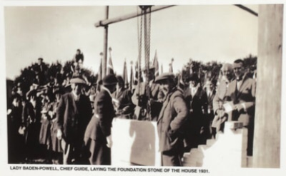
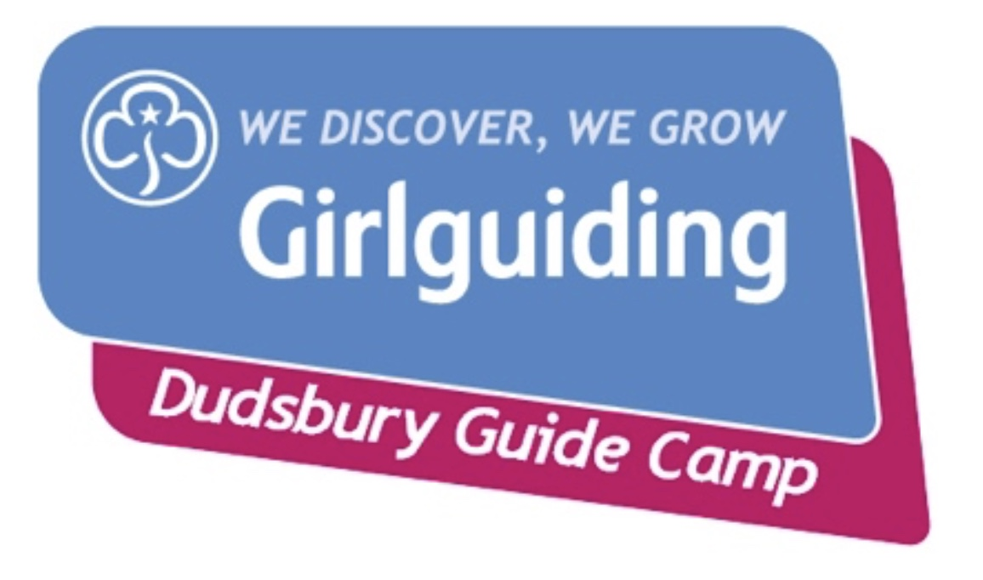

DUDSBURY BIG ART EXHIBITION

Celebrate 90 years since Lady Baden Powell laid the stone of The House at Dudsbury, with your Unit and make a big piece of art for a fabulous celebratory outdoor exhibition

Make your artwork colourful and waterproof and windproof!

Recycle, reclaim, reuse - there’s lots of free stuff out there, so use it!

Your Unit’s artwork will be exhibited at Dudsbury Guide Camp during October.
Everyone coming to Dudsbury and walking the new footpath will see it.

Light your artwork with solar lights to make a magical nighttime exhibition.

Here are two examples of big art using recycled materials ......

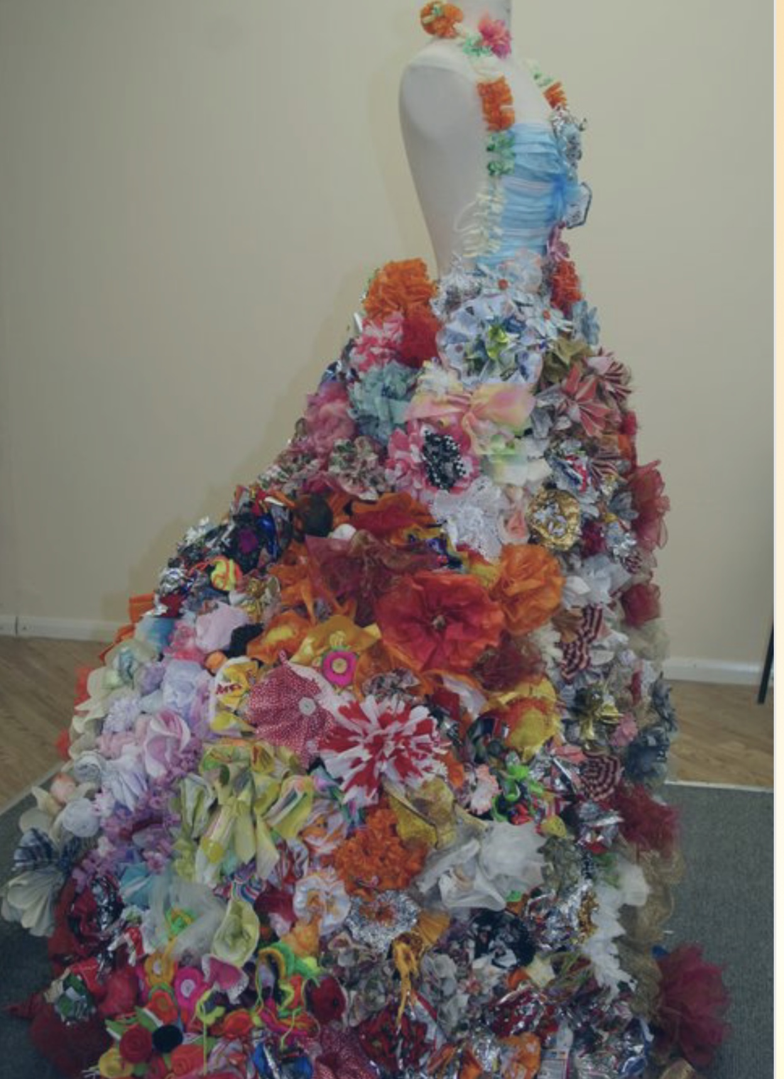

This piece was made by resident of Colchester. They made over 500 flowers using recycled materials like crisp packets, biscuit packets, tea bags, tin foil, fruit net bags.....

Isn’t it fabulous!

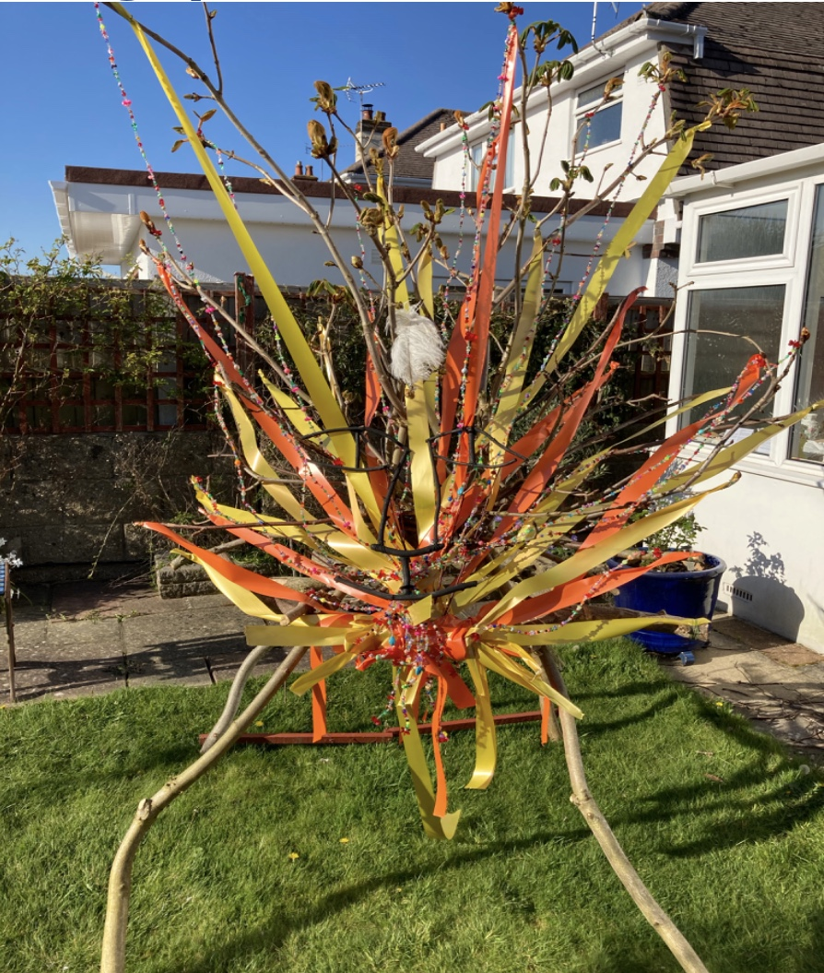

This piece was made from branches of a chestnut tree that was being cut down. It is decorated with ribbon and hundreds of beads strung on wire. If you look closely, you can see the lions face made using sticks painted black.

Don’t forget, acrylic paint is cheap and waterproof when dry
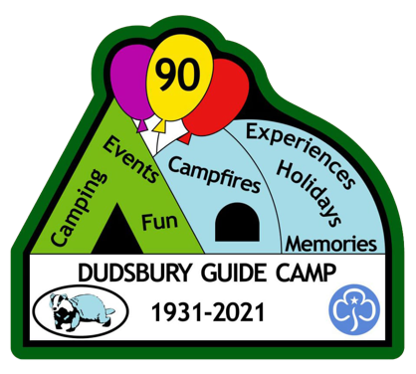

Look online for Big Art ideas

